**What happened in the 2024 UK general election?**

***Teaser: Ten charts tell the story of Labour’s landslide victory in the UK’s 2024 general election, putting it in historical perspective and, in the data on turnout, revealing the disengagement of some voters.***

Main text:

On 4 July, the UK voted the Keir Starmer’s Labour into power with a landslide majority. Labour won a total of 412 seats (to the Conservatives’ total of 121), an increase of 211 seats since the 2019 election. This gives them a large majority as they form a government for the first time in 14 years.

Supporters argue that the new prime minister and his cabinet now have a strong mandate to govern, while critics point to Labour only getting 34% of the overall vote. This may have been a [tactical move](https://www.theguardian.com/politics/article/2024/jul/07/labour-safe-seats-marginals-landslide-victory-vote) to ensure victory, but some see it as a ‘[double-edged sword](https://www.ft.com/content/1e97d539-ec98-4cdc-9c8d-69fd156ae84e)’.

In this article, we look at the 2024 general election results, how they compare to elections over the past 100 years and what they tell us about the political mood of the country.

**Labour’s seat share in historical perspective**

Keir Starmer’s performance in the 2024 election places him among the top Labour leaders, with a seat share close to that achieved by Tony Blair in 1997 and 2001.

#### Figure 1: Share of seats, 1924-2024

##### Source: House of Commons Library, General Election Results (1918-2019); Author’s calculations

**Labour’s vote share in historical perspective**

In terms of vote share, Labour’s performance in 2024 ranks below average compared with past leaders. This discrepancy – where a party wins a disproportionately higher number of seats relative to their vote share – suggests that the victory margins were very narrow this time around. Indeed, analysis of the seats gained by Labour reveals that the average victory margin was only 12%, indicating tightly contested races.

#### Figure 2: Share of vote, 1924-2024

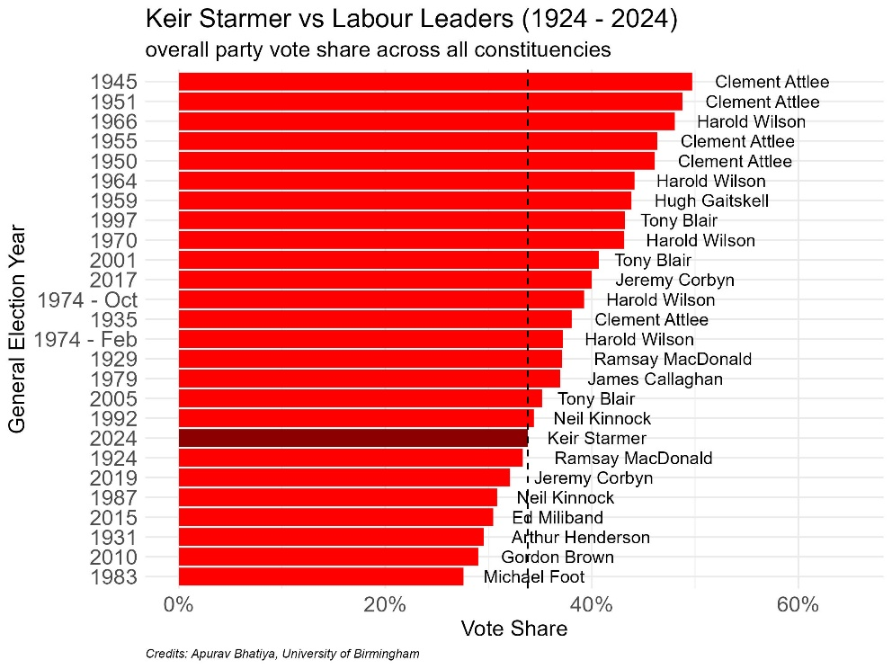

##### Source: House of Commons Library, General Election Results (1918-2019); Author’s calculations

**Labour leader’s personal vote share**

Typically, changes in the number of seats won by a party and the party leader’s personal vote share are closely aligned. For example, in the 1997 election, Labour gained 22% more seats in parliament, and Tony Blair’s vote share in his Sedgefield constituency increased by 11%.

Here, the 2024 election is an anomaly: while Labour secured 34% more seats compared with the 2019 election, Starmer's vote share in his own constituency decreased by 16%.

#### Figure 3: Change in seat share compared with party leader’s personal vote share

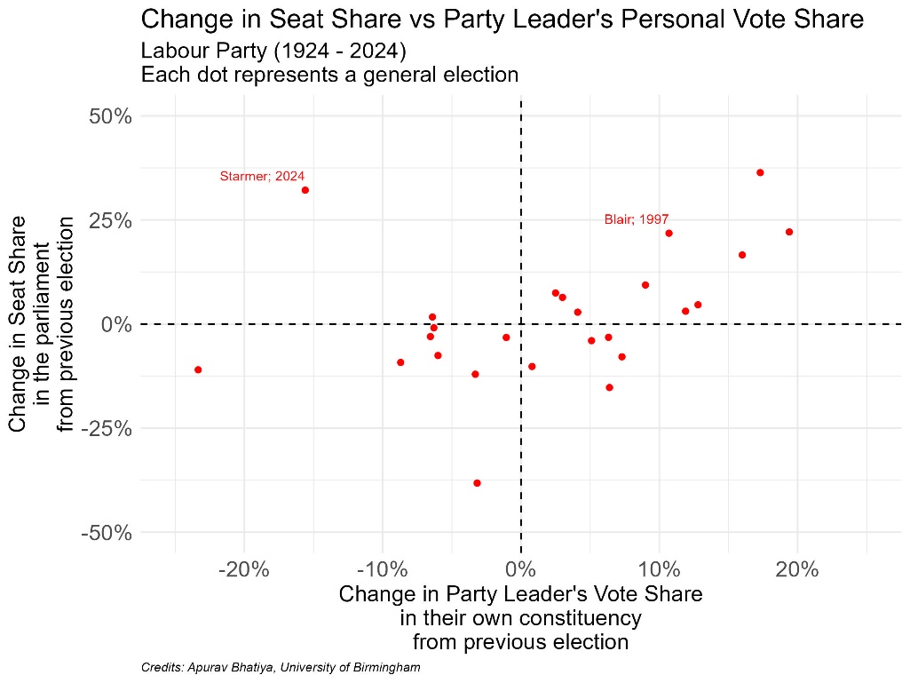

##### Source: House of Commons Library, General Election Results (1918-2019); Author’s calculations

**Labour ministers’ personal vote share**

Keir Starmer was not the only Labour candidate to lose votes in his or her constituency. The majority of the Labour MPs announced as cabinet ministers saw their vote share decline: Rachel Reeves, chancellor (a 6% decrease), Angela Rayner, deputy prime minister and secretary of state for housing, communities and local government (a 4% decrease), Wes Streeting, health and social care secretary (a 17% decrease) and David Lammy, foreign secretary (a 19% decrease).

#### Figure 4: Candidates’ vote share in their own constituency

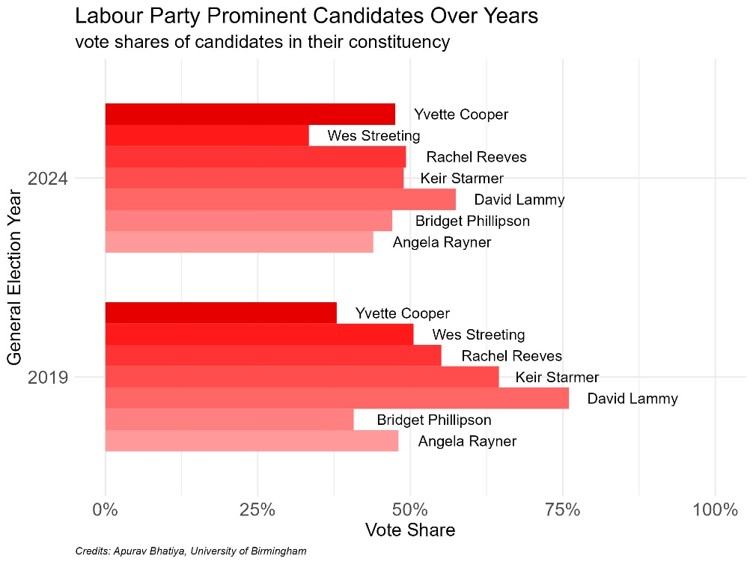

##### Source: House of Commons Library, General Election Results (1918-2019); Author’s calculations

**The two main parties’ seat and vote shares in historical perspective**

The 2024 election was not just a historic win for Labour. A number of other political parties got their highest shares of votes and seats in this election.

This increase suggests a notable shift in voter support away from the traditional two-party dominance towards alternative parties, indicating a possible fragmentation of the political landscape in the future.

#### Figure 5: Seat share of parties other than Conservative and Labour, 1924-2024

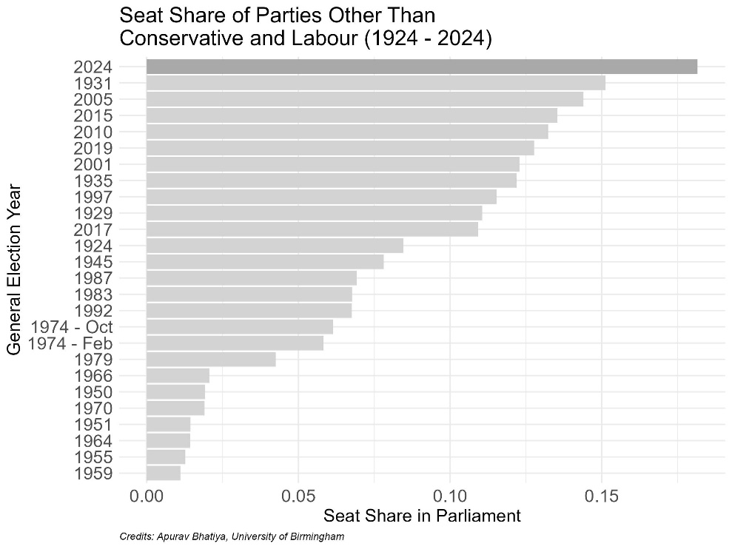

##### Source: House of Commons Library, General Election Results (1918-2019); Author’s calculations

**The Liberal Democrats’ performance**

The Liberal Democrats made significant in-roads, winning 72 seats. The majority of these were in constituencies where the Conservatives were incumbents, and particularly when an incumbent Conservative MP was not standing in the 2024 election.

Comparably, the Lib Dems did not manage to win a single seat in constituencies with an incumbent from Labour. Labour retained over 97% of such seats. The Conservatives managed to retain only a third of the constituencies where they were incumbents.

#### Figure 6: Share of seats gained/retained by incumbency status

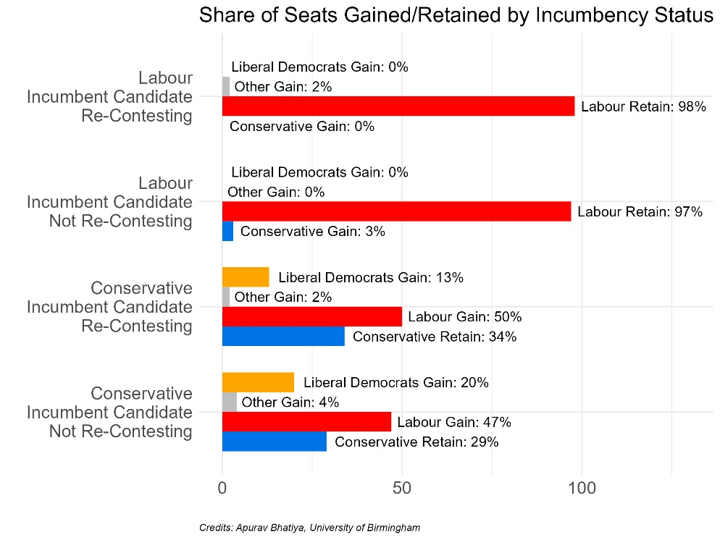

##### Source: Democracy Club (www.democracyclub.org.uk); Author’s calculations

**Voter turnout**

At around 60%, the overall turnout in this election reached a historic low. In areas with a Labour incumbent, voter engagement was notably lower, reflected by an average turnout of around 55%.

Further, over 75% of the constituencies with a Labour incumbent had a turnout below the national average. This suggests lower mobilisation efforts and potentially less political activity or voter interest in these regions. This may have been exacerbated by the outcome of opinion polls in the last six months that had significantly favoured Labour.

In constituencies with a Conservative incumbent, the turnout was also at lower levels but at least comparable to previous elections: 2010 (65%), 2015 (66%), 2017 (69%), and 2019 (68%).

#### Figure 7: Voter turnout by incumbency status

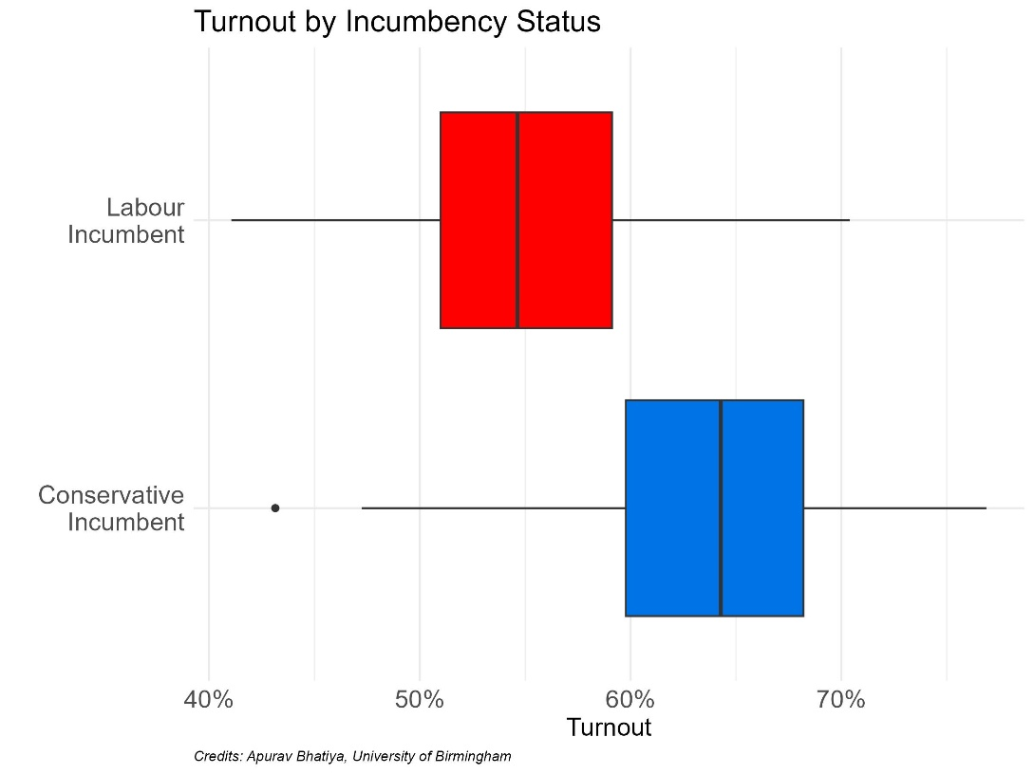

##### Source: Financial Times, General Election 2024 Results; Author’s calculations

**The far right’s vote share**

While the Lib Dems secured 72 seats – placing them third in terms of seats in Westminster – they received 12.2% of the vote. Reform UK received a larger share of the votes (14.3%), but only secured five seats.

Reform ranked third in terms of overall votes secured and garnered half a million more votes than the Lib Dems. The distribution of the Reform vote share in 2024 is comparable to the UKIP vote share in the 2015 election, which preceded the 2016 referendum on Brexit. The rise in the vote share for the far right mirrors the trend observed in other European countries, suggesting substantial and persistent support for far-right policies amid continuing political and economic uncertainties.

#### Figure 8: Constituency level far right vote share 2010-24

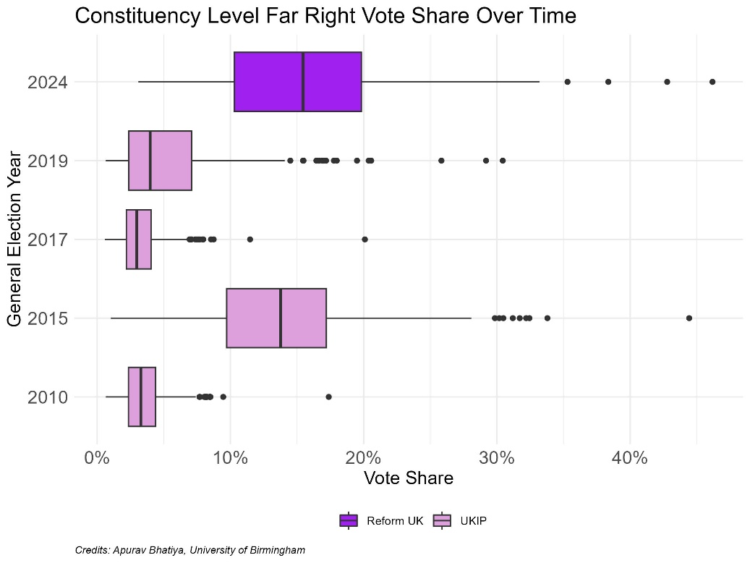

##### Source: House of Commons Library, General Election Results (1918-2019); Author’s calculations

**Vote share and Brexit**

Reform have gained significant traction in constituencies with a higher proportion of the electorate who voted to leave the European Union (EU) in the 2016 referendum, indicating a persistence of more right leaning and pro-Brexit sentiments in those constituencies.

The Greens, on the other hand, gained most of their votes in constituencies with a higher predicted vote to remain in the EU. The Greens won four seats in 2024, with 6.7% of the national vote.

#### Figure 9: Vote share by party (2024) and predicted leave vote (Brexit referendum)

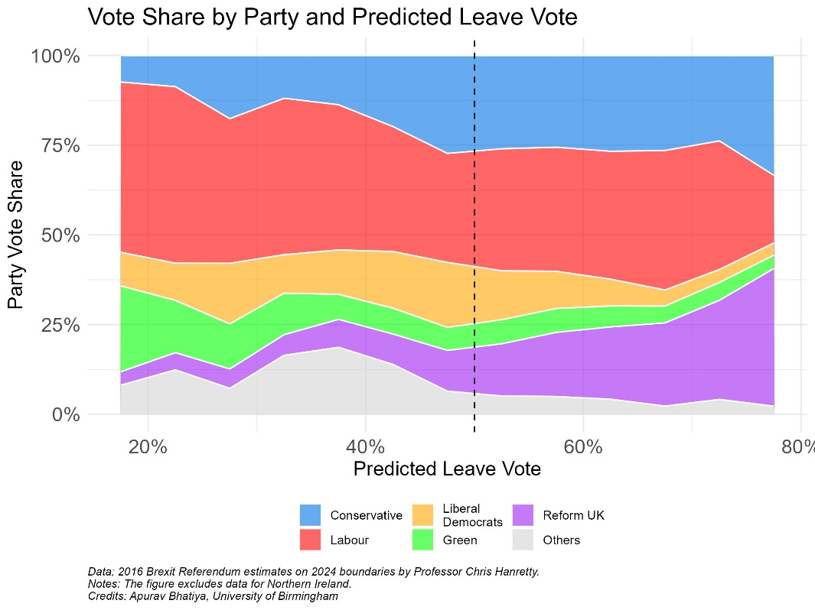

##### Source: 2016 Brexit Referendum estimates on 2024 boundaries by Professor Chris Hanretty; Author’s calculations

##### Note: Figure excludes data for Northern Ireland.

**Voting and Muslim populations**

Historically, Labour has had strong support in constituencies with higher Muslim populations. This election saw a significant fall in Labour’s vote share in these areas and an increase in vote share for other parties and independent candidates who were more [favourable to Gaza](https://www.bbc.co.uk/news/articles/c9e9ydj215yo).

#### Source: Party vote share by proportion of Muslim population

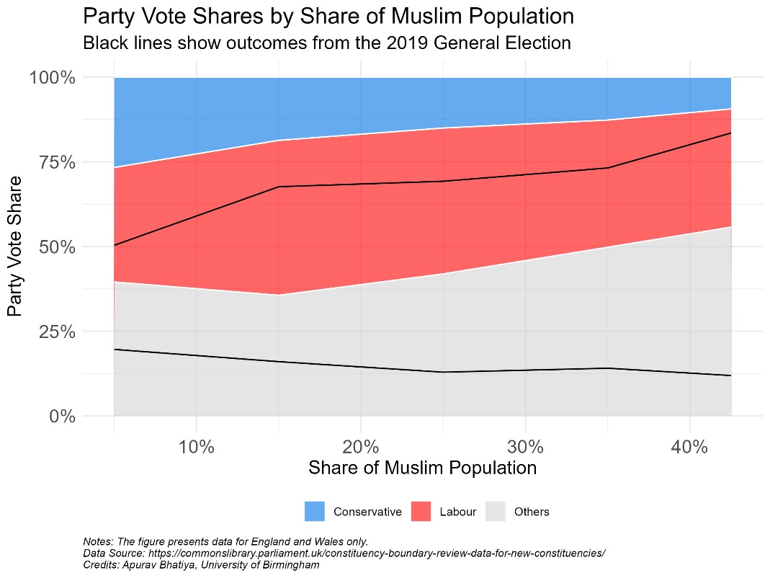

##### Source: House of Commons Library, Data for New Constituencies; Author’s calculations

##### Note: Data for England and Wales only.

**Conclusion**

The 2024 general election marked the worst performance in the Conservative party’s history, with many prominent Conservative figures, including former Prime Minister Liz Truss and notable MPs like Penny Mordaunt, losing their seats. Labour’s landslide victory can largely be attributed to voters’ dissatisfaction with the Conservative government's handling of the cost-of-living crisis and internal party conflicts, suggesting that the result was more an anti-Conservative vote than a pro-Labour one.

However, it is noteworthy that the Labour Party faced its own challenges, as several newly elected cabinet ministers and even the Labour leader himself experienced a loss in vote share within their constituencies. Looking ahead, the future of British politics will likely be shaped by how effectively Labour can address the pressing issues, as well as how the Conservative Party reorganizes and responds to this historic defeat.

### Where can I find out more?

### Who are experts on this question?

John Curtice

Author: Apurav Bhatiya

Topics:

Attitudes, governance

Nations, regions, cities

Lessons from history

Sidebar links:

[Ideas for the UK – election economics collection](https://www.economicsobservatory.com/ideas-for-the-uk-election-economics-final-week)

[How do the views of experts and the public differ on big policy questions?](https://www.economicsobservatory.com/how-do-the-views-of-experts-and-the-public-differ-on-big-policy-questions)

[Principles of motion: how should policy-makers think about human behaviour?](https://www.economicsobservatory.com/principles-of-motion-how-should-policy-makers-think-about-human-behaviour)

[Does public trust in government matter for effective policy-making?](https://www.economicsobservatory.com/does-public-trust-in-government-matter-for-effective-policy-making)